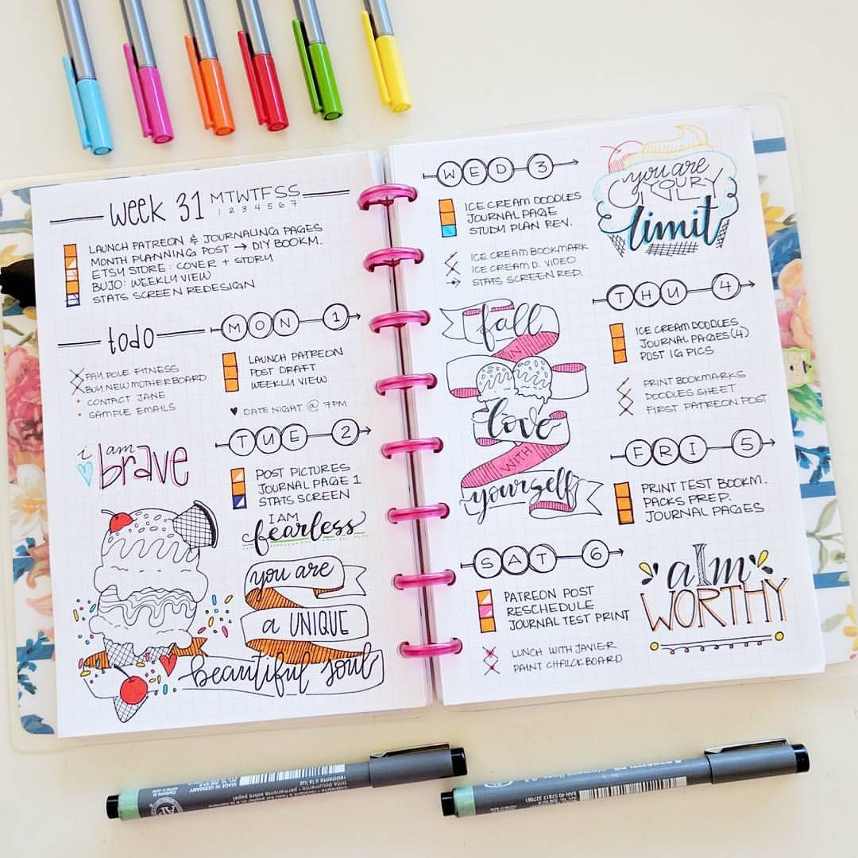

**BULLET JOURNAL**

RYANA CALENDARS is selling wonderful BULLET journals! at reasonable prices. It contains beautiful and designable covers!

**RS 880**